SLEEK ROTHC TRAINING FOR SOIL-EWG HELD AT THE UNIVERSITY OF NAIROBI’S LARMAT GIS LABORATORY
The University of Nairobi - Department of LARMAT, together with other institutions, is involved in development of a system for estimation of land based emissions estimation for Kenya (SLEEK).

The various institutions have been mandated to deliver specific aspects - also referred to as element working groups - (Forest biomass, Land cover, soil carbon, crop growth processes and Climate parameters) of the SLEEK programme. The UoN together with Kenya Agricultural and Livestock Research Organization (KALRO) is tasked with the responsibility of estimating soil based emissions (i.e. for the soil Carbon element working group). The respective scientists have identified Roth-C model as the appropriate tool of choice in estimating the soil carbon emissions.

To this end, a consultative cum training meeting on Roth-C model was held on July 20-24, 2015 at the LARMAT GIS laboratory. About 10 participants, drawn from the UoN, KARLO and MoALF attended and participated in the training. The training enhanced the modeling capacity of the Soil-EWG, a prerequisite for estimation of soil based carbon emissions accounting. For more information, visit http://www.sleek.environment.go.ke/

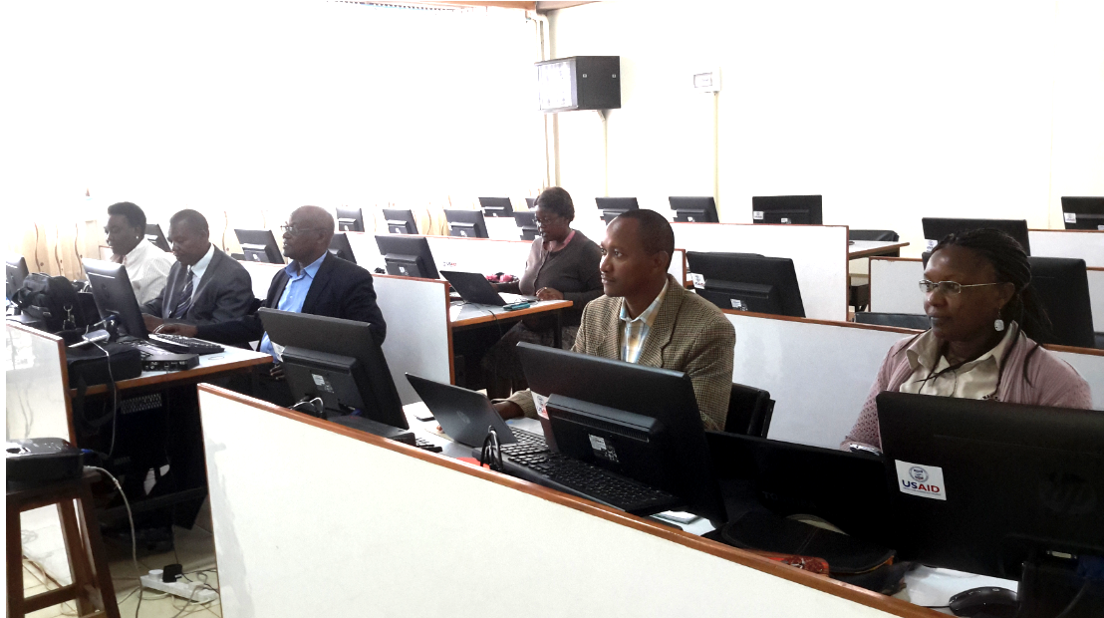
Participants follow keenly during the RothC training

